STANDARD SUPPLEMENTARY REGULATIONS
PART ONE
1. JURISDICTION
This event is a Clubsport Advanced Bent Sprint, promoted by the Hamilton Car Club at Head & Stoke Road, Maungatautari, Cambridge, to be held on Sunday March 20th 2022.

The Meeting will be held under these Supplementary Regulations, the MotorSport NZ National Sporting Code and its Appendices and Schedules particularly Appendix Five, Schedule C being the Standing Regulations for all ClubSport Events and Appendix Two, Schedule A – Driver and Vehicle Safety Requirements.

The MotorSport NZ Permit Number is: 220043
2. MAJOR OFFICIALS [5]
2.1 Clerk of the Course: Glenn Climo
Organiser: Glenn Climo
Secretary: Bill McEwan
Motorsport NZ Steward: Bob Cullinane
Competitor Relations Officer: NA
Chief Scrutineer: Sean Elder
Results: Bruce Clothier
Judges: All Event Officials
2.2 The address and contact phone numbers for all matters pertaining to the event are:
The Secretary,
Hamilton Car Club Inc
P. O. Box 14142
Hamilton

Email: events@hamiltoncarclub.org.nz
Mob: 021769615 Glenn Climo
3. EVENT DESCRIPTION:
3.1 The event will be held on March 20th, 2022 and is a 3.5km (approx.) tarmac bent sprint, held on Stoke and Heads Road, Maungatautari, Cambridge.

Event starts at 9:00am with a Drivers Briefing, followed by reconnaissance run for new competitors.

9-30am (Practice) estimated and 10-00am 1st timed run.
There will be one practice run and three timed runs, of which the fastest time from these three runs will count towards the overall results.

Event finishes: (before) 5-00pm

3.2 Classes: Vehicles will be divided into the following classes:
Class A 0-1300cc (2WD)
Class B 1301-1600cc (2WD)
Class C 1601-2000cc (2WD)
Class D 2001 and over (2WD)
Class E 4WD
Class F Crosscars
4. ENTRIES:
4.1 Entries shall be made through the MotorSport Online system https:/possum.motorsport.org. nz. Any entry will not be deemed valid until payment is received.
All such entries must be made on the correct form, must be complete in all detail, and accompanied by the appropriate fees.
Organisers reserve the right to refuse any entry in accordance with the prescribed provisions of the National Sporting Code.
4.2 Opening and Closing Dates:
Entries open with the publication of these regulations and close (at normal fees) on March 19th, 2022 1700 at Hamilton Car Clubrooms, Vaile Road, Hamilton.
Entries received after the normal fee-closing date are subject to late fee.
4.3 Entry Fees:
The Entry fee for this event is $150, including GST per competitor.
The late entry fee for this event is $180, including GST per competitor
Entry is payable to:
Hamilton car club
06 0317 0335984 00
Please use your surname as the reference.

4.4 Number of Starters:
The maximum number of starters will be 60. Any additional entries received will be placed on the reserve list in order of receipt. The minimum number required shall be 20 entrants.
5. COMPETITOR REQUIREMENTS and UNDERSTANDING:
5.1 Licence Requirements:
All drivers must hold as a minimum an M Grade Competition Licence and current membership with a member club.
5.2 Competitor Understanding:
In submitting the entry competitors (Entrant and Drivers) are deemed to fully understand the MotorSport NZ National Sporting Code and its relevant Appendices and Schedules. In particular:
•The National Sporting Code Articles pertaining to protests and competitors obligations, and
• Appendix Five, Schedule C.
5.3 All competitors shall wear safety apparel in compliance with Appendix Two, Schedule A.
5.4 This event will be held within the Waikato region which is currently under “RED” at the time of publishing. It is mandatory that all Competitors, their Crews, Supporters, and all event personnel show their “My Vaccine Pass” verification to the staff at the entrance gate to gain access to the Event and Venue. If you do not have a Vaccine Pass you will not be able to enter the Venue. “No exceptions”. Face masks are mandatory at all times, except for when the Driver is in their vehicle
6. ELIGIBLE VEHICLES
6.1 Compliance: All vehicles shall comply with Appendix Five Schedule C and Appendix Two Schedule A of the current MotorSport Manual unless stated otherwise in these supplementary regulations.
7. DOCUMENTATION & SCRUTINEERING AUDIT INSPECTION
7.1 Documentation: Will take place at Hamilton Car Club, 116 Vaile Road, Newstead, Hamilton on Saturday 19th March commencing at 3.00pm and concluding at 5.00pm, also at the venue on the morning of the event at the paddock on the corner of Maungatautari Road and Head Road (The Event Service Park) from 7am until 8:00am.
To be compliant with the COVID-19 Protection Framework masks will be mandatory at events for event personnel and competitors alike..
You will be required to show your competition licence, civil driver’s licence, current club membership and My Vaccine pass which is mandatory for all Motorsport NZ events.
Social distance where practicably possible for the safety audit, documentation and drivers briefing.

Please Note: All entries and entry fees need to be received by 1700 on 19th March 2022.
7.2 Scrutineering Audit Inspection: Will take place at the same times mentioned above, or as required if remote scrutineering is needed.
Competitors will be advised at documentation if their vehicle has been selected for audit.
7.3 Drivers’ Briefing: This will be held at the service park commencing at 9:00am approximately. Attendance by all drivers is compulsory – a roll call will be taken and failure to attend will result in a penalty. Social distancing will be required under the Covid-19 requirements.

8. POSTPONEMENT CANCELLATION ABANDONMENT & ORGANISERS’ RIGHTS:
8.1 Pursuant to national Sporting Code Article 13, the organisers advise that if less than 20 entries are received by the entry closing date the meeting may be postponed or cancelled.
Should the event be postponed, or cancelled, due to changing COVID-19 alert levels, or for reasons beyond the club’s control, a full refund will be available, or should you wish, the entry fee can be transferred to another Hamilton Car Club organised event.
9. OFFICIAL BULLETINS
9.1 Official Bulletins may be issued in accordance with the provisions of the National Sporting Code.
10. COVID-19 PROTOCOLS

10.1 A Vaccine Pass is required for all competitors and their family members, crew and spectators.

10.2 Everyone is required to Scan in or Sign in with the Marshal at Club Bus.

10.3 Please maintain social distancing of 1m.

10.4 Masks strongly recommended to be worn.

11. GENERAL INFORMATION

11.1 PASSENGERS: May only be carried in accordance with Appendix Five, Schedule C Article 6.2. A coloured wristband will be issued after the passenger and driver have signed the indemnity form, which will be at documentation, or at the bus during the event.
11.2 Alcohol is not permitted to be consumed by any competitor or their crew at the event before or during the day’s competition.
11.3 RESULTS:
Provisional results will be posted at the Club Bus. If possible, times will be posted during the day.

11.4 SPECTATORS PROVISIONS.
There are no spectator points for this event.

11.5 EVENT DIRECTIONS.
Competitor access to the venue is from Hamilton head south through Cambridge on SH 1. Once through Cambridge turn right after the bridge (at the bottom of the hill) signposted for Te Awamutu. Follow this road for 1.9km (Straight through at the roundabout) then turn left onto Browning Street, signposted for Lake Karapiro. Follow this road for 15km past Karapiro Lake Domain before turning left onto Head Road. Parking will be in the paddock for all vehicles and trailers, please do not park on the side of the road, in the interests of safety and as part of our safety plan requirements.

11.6 Food and drinks will be available near the service park area, please adhere to current Covid-19 requirements for the day.

11.7 No dogs, smoking or alcohol permitted at the venue.

11.8 Please collect all rubbish in the interest of good public relations.

11.9 All competitors must supply and service on a suitable ground sheet.

11.10 Servicing is only permitted in the designated service park or adjacent area.

11.11 All competitors will be required to pay for any fencing or property damage they may cause within seven days of the account being received. Where more than one competitor goes through the same section of fence, the account will be divided evenly to the offending competitors.

11.12 On release of these regulations, any competitor seen travelling the course before the start of the event will be excluded and fined in accordance with N.Z. Motor Sport manual #36.

11.13 Dual drivers must make themselves known to the event organisers at documentation to receive suitable starting numbers.

11.14 Starting order will be posted at the Club Bus, at the Car Park area. Competitors must start in numerical order unless instructed otherwise by the Clerk of the course.

Please bring a volunteer to assist with the running of the day if you are able. Please message the organiser confirming this when entering the event. They will get to see all the cars and enjoy the day from a different perspective.

There will be assistance given to the role or responsibility they will be doing during the day. Remember, without volunteers we do not get to run events like this.

EVENT MAP: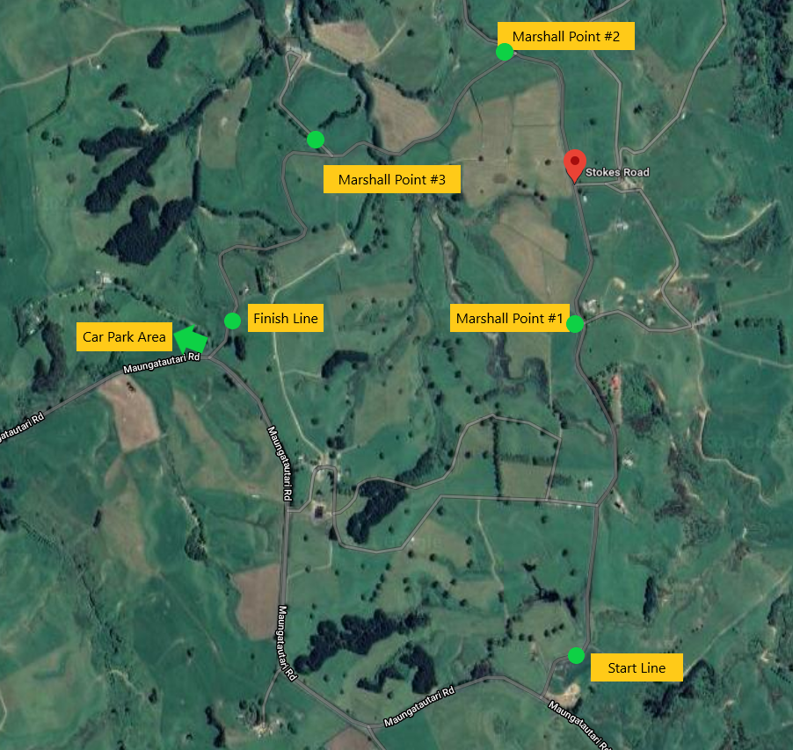

CSport003 – Supplementary Regs Template- ClubSport (01/21)

